- 修改options.mak, 建立搜狗输入法选项
Option 改为搜狗输入法__IME_MMI_SG__
例如目前是__IME_MMI_MY__
修改前为
# Description = [MMI] IME solution (If we don't have any ime solution, please select __IME_MMI_DUMMY__.)
# Pre_Condition_On = N/A
# Pre_Condition_Off = N/A
# Option_Selection = __IME_MMI_MY__, __IME_MMI_ZI__, __IME_MMI_DUMMY__
PP_OPT_COMMON += __IME_MMI_MY__
修改后为
# Description = [MMI] IME solution (If we don't have any ime solution, please select __IME_MMI_DUMMY__.)
# Pre_Condition_On = N/A
# Pre_Condition_Off = N/A
# Option_Selection = __IME_MMI_MY__, __IME_MMI_ZI__, __IME_MMI_DUMMY__, __IME_MMI_SG__
PP_OPT_COMMON += __IME_MMI_ SG __

- 确认为中文版本或者无中文版本
[注意]
分为有包含中文输入法与不包含中文输入法两种方式(对于海外产品不包含中文输入法可节省空间)

A.包含中文输入法则关掉IME_SG_FOREIGN_ONLY
# Feature_Name = Use pure foreign lib for IME SG
# Description = [MMI] Use pure foreign lib(Disable simple chinese) for IME SG to save more code size
# Pre_Variable_True = IME_SOLUTION(__IME_MMI_SG__)
# Pre_Variable_False = N/A
# Option_Selection = TRUE, FALSE
IME_SG_FOREIGN_ONLY = FALSE

B.不包含中文输入法则打开IME_SG_FOREIGN_ONLY
# Feature_Name = Use pure foreign lib for IME SG
# Description = [MMI] Use pure foreign lib(Disable simple chinese) for IME SG to save more code size
# Pre_Variable_True = IME_SOLUTION(__IME_MMI_SG__)
# Pre_Variable_False = N/A
# Option_Selection = TRUE, FALSE
IME_SG_FOREIGN_ONLY = TRUE

- 选择其它需要的语言

举例: 将所需语言表列并以空白分隔, 其于不需要的语言不要打开, 否则会多占空间, 一次不能同时开超过5种语言

# Feature_Name = IME SG input language
# Description = [MMI] IME SG input language (!!At most 5 languages can be included. All languages are separated by space!!)
# Pre_Variable_True = IME_SOLUTION(__IME_MMI_SG__)
# Pre_Variable_False = N/A
# Option_Selection = __IME_SG_CHINESE_S__ __IME_SG_ARABIC__ __IME_SG_BENGALI__ __IME_SG_CZECH__ __IME_SG_DUTCH__ __IME_SG_ENGLISH__ __IME_SG_FRENCH__
# __IME_SG_GERMAN__ __IME_SG_GREEK__ __IME_SG_HINDI__ __IME_SG_INDONESIAN__ __IME_SG_ITALIAN__ __IME_SG_MALAY__ __IME_SG_PERSIAN__
# __IME_SG_POLISH__ __IME_SG_PORTUGUESE__ __IME_SG_RUSSIAN__ __IME_SG_SPANISH__ __IME_SG_THAI__ __IME_SG_TURKISH__ __IME_SG_VIETNAMESE__
IME_SG_LANG_SUPPORT = __IME_SG_CHINESE_S__ __IME_SG_ENGLISH__
修改完执行options.mak , 执行tng/configure.pl

- 拿现有的lang pack file修改另存新檔, 来建立新的lang pack

找到现有的langpack file, 编辑他, 例如现有的LangPack0000.ini内容为
[Build]
CUS_File=LangPack0000
[String_Table]
Default_String_Table=CHINESE_S
String_Table_00=CHINESE_S
String_Table_01=ENGLISH
[Font]
Font_00=CH_date
Font_01=CH_supper_small
Font_02=CH_supper_small_date
Font_03=CH_zi8
Font_04=CH_zi8_supper_small
Font_05=EN_normal
Font_06=EN_supper_small
Font_07=NUM_extra_small_numeric
Font_08=NUM_extra_small_symbol
Font_09=Num_large_numeric
Font_10=Num_large_symbol
Font_11=Num_large_timer
Font_12=Num_normal_numeric
Font_13=Num_normal_symbol
Font_14=Num_small
Font_15=Num_small_numeric
Font_16=Num_small_symbol
Font_17=Num_supper_large_numeric
Font_18=Num_supper_large_symbol
Font_19=Symbol_normal_1
Font_20=Symbol_normal_2
Font_21=Symbol_normal_3
Font_22=Symbol_supper_small_1
Font_23=Symbol_supper_small_2
Font_24=Symbol_supper_small_3
Font_25=CH_normal
[IME]
Default_Writing_Language=CHINESE_S
IME_00=MY_CHINESE_S
IME_01=MY_ENGLISH
[Handwriting]
Handwriting_00=HW_SINOVOICE_CS_EN
修改成
[Build]
CUS_File=LangPack0000
[String_Table]
Default_String_Table=CHINESE_S
String_Table_00=CHINESE_S
String_Table_01=ENGLISH
[Font]
Font_00=CH_date
Font_01=CH_supper_small
Font_02=CH_supper_small_date
Font_03=CH_zi8
Font_04=CH_zi8_supper_small
Font_05=EN_normal
Font_06=EN_supper_small
Font_07=NUM_extra_small_numeric
Font_08=NUM_extra_small_symbol
Font_09=Num_large_numeric
Font_10=Num_large_symbol
Font_11=Num_large_timer
Font_12=Num_normal_numeric
Font_13=Num_normal_symbol
Font_14=Num_small
Font_15=Num_small_numeric
Font_16=Num_small_symbol
Font_17=Num_supper_large_numeric
Font_18=Num_supper_large_symbol
Font_19=Symbol_normal_1
Font_20=Symbol_normal_2
Font_21=Symbol_normal_3
Font_22=Symbol_supper_small_1
Font_23=Symbol_supper_small_2
Font_24=Symbol_supper_small_3
Font_25=CH_normal
[IME]
Default_Writing_Language=CHINESE_S
IME_00=SG_CHINESE_S
IME_01=SG_ENGLISH
[Handwriting]
Handwriting_00=HW_SINOVOICE_CS_EN
另存新档为LangPack0000SG..ini (存在相同目录中)
[进阶] 请确认MY_CHINESE_S.xml 与SG_CHINESE_S
.xml 都存在ime 目录中了, 才可以这样直接改, EX: ..\proj\sc\customer\default\src\mmi\resource\QVGA\system\global\project\ime
或是proj\sc\customer\default\src\mmi\resource\Control_Files\system\global\project\ime

SG_CHINESE_S.xml, 在 XRG build IME 的过程中建立的中继档案就是SG_CHINESE_S.bin。bin 档案位于 ..\proj\sc\customer\default\src\mmi\resource\project\3rd 。BIN文件是跟着语言跑。

- 修改commonPortait.xml 来build刚刚另存新档的LangPack0000SG.ini
建议一次只build一个language pack, 原因同2. 因为language 在刚刚已经选定, 假设LangPack0001SG..ini 的language为ARABIC, ENGLISH,PERSIAN, LangPack0005SG..ini 的language为ENGLISH, RUSSIAN, 请先开ARABIC, ENGLISH,PERSIAN, build LangPack0001SG..ini, 再关掉ARABIC, PERSIAN, 开RUSSIAN, build LangPack0005SG., 以免不必要的语言包(lib)多占空间。

找到xlangpack_list
<xlangpack_list>
<xlangpack>LangPack0000</xlangpack>
<xlangpack>LangPack0001</xlangpack>
<xlangpack>LangPack0002</xlangpack>
<xlangpack>LangPack0003</xlangpack>
<xlangpack>LangPack0004</xlangpack>
<xlangpack>LangPack0005</xlangpack>
<xlangpack>LangPack0006</xlangpack>
<xlangpack>LangPack_Vector_CS</xlangpack>
<xlangpack>LangPack_Latin</xlangpack>
<xlangpack>LangPack_Vector_E</xlangpack>
<xlangpack>LangPack_Vector_M</xlangpack>
</xlangpack_list>

修改成如下
<xlangpack_list>
<xlangpack>LangPack0000_SG</xlangpack>
</xlangpack_list>

- 修改VC solution file
6.1变更App_3rd project
删除原本的App_3rd project
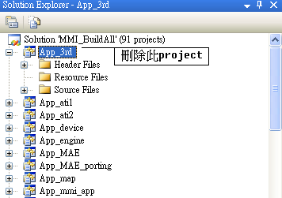

新增以下路径的project：
proj\MStarStudio_UP\MStarKernel\Task\Xime\Task_ime_sg.vcproj
新增后的App_3rd应该如下图所示：
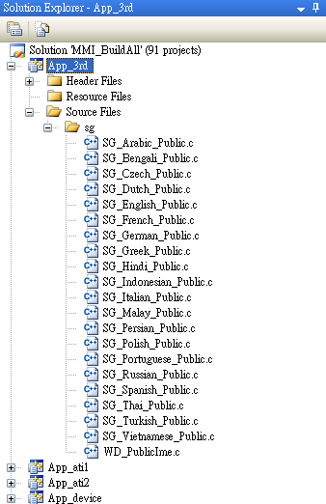

6.2新增搜狗输入法的library到
a. 修改MStarMMI properties
b. Linker --> Input --> Additional Dependencies
c. 新增以下的library
SGIME_ARA_WIN32.lib
SGIME_BEN_WIN32.lib
SGIME_CN_WIN32.lib
SGIME_CZE_WIN32.lib
SGIME_DUT_WIN32.lib
SGIME_ENG_WIN32.lib
SGIME_FOREIGN_ENGINE_WIN32.lib
SGIME_FRE_WIN32.lib
SGIME_GER_WIN32.lib
SGIME_GRE_WIN32.lib
SGIME_HIN_WIN32.lib
SGIME_IND_WIN32.lib
SGIME_ITA_WIN32.lib
SGIME_MAL_WIN32.lib
SGIME_PER_WIN32.lib
SGIME_POL_WIN32.lib
SGIME_POR_WIN32.lib
SGIME_RUS_WIN32.lib
SGIME_SPA_WIN32.lib
SGIME_THA_WIN32.lib
SGIME_TUR_WIN32.lib
SGIME_VIE_WIN32.lib
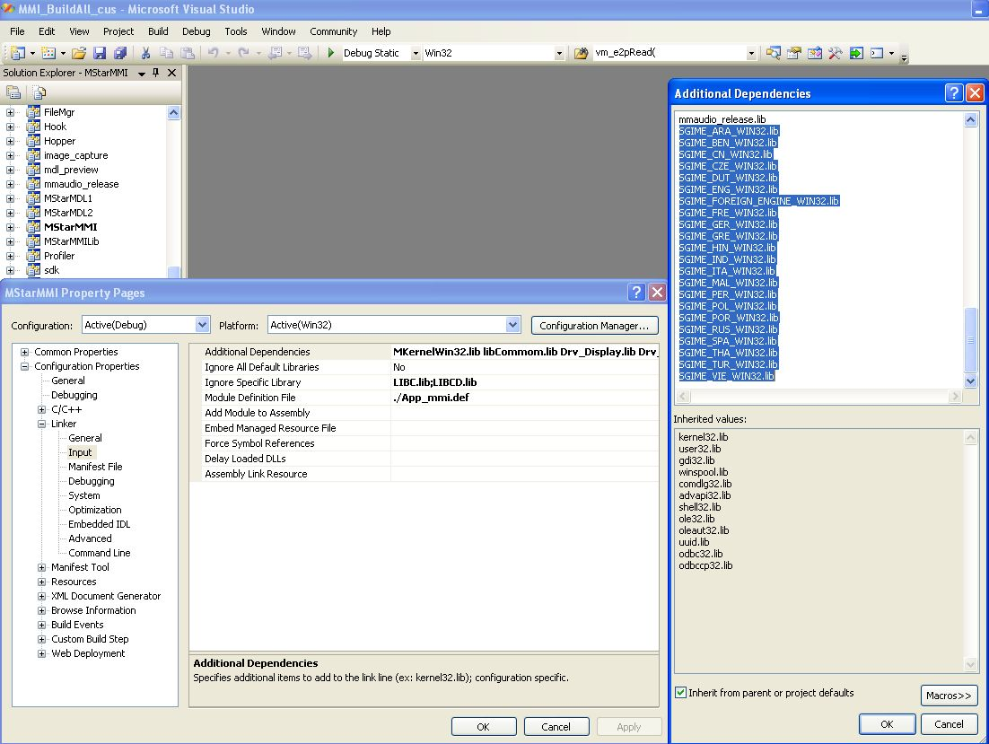

- 修改完成
完成前六个步骤后,即可开始进行config以及build的动作

